IMPORTANT QUESTIONS COSM

1. Define population correction factor

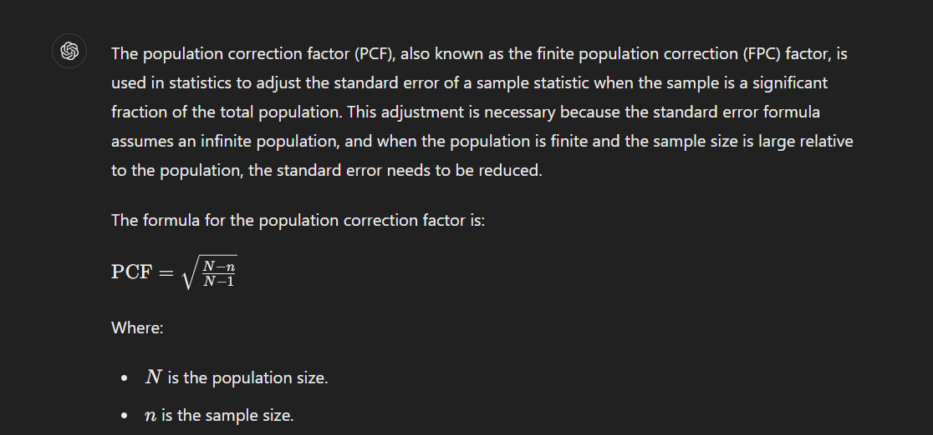

1. A sample of size 10 was taken from a population S.D. of sample is 0.03. Find the maximum error with 99% confidence

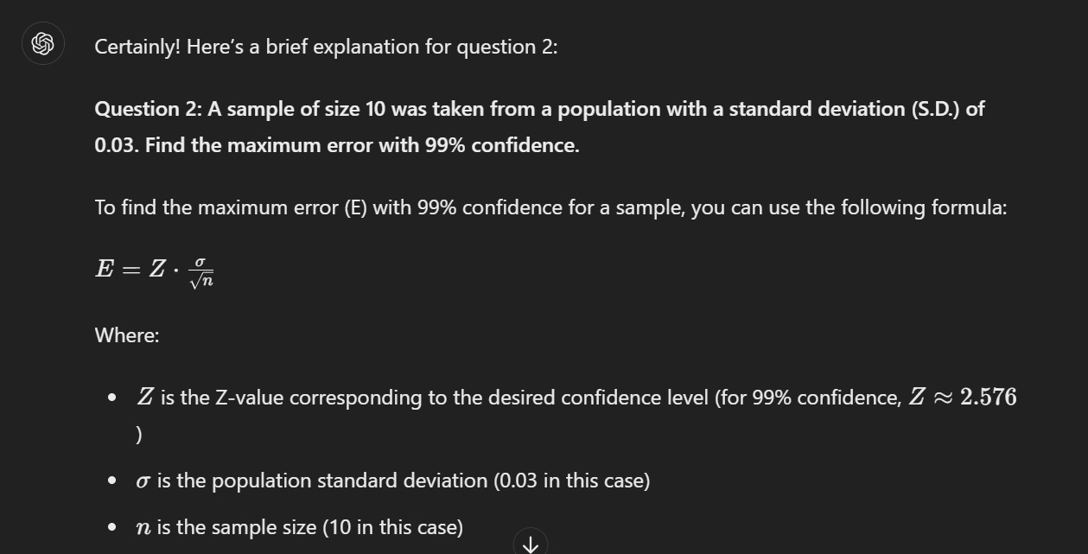

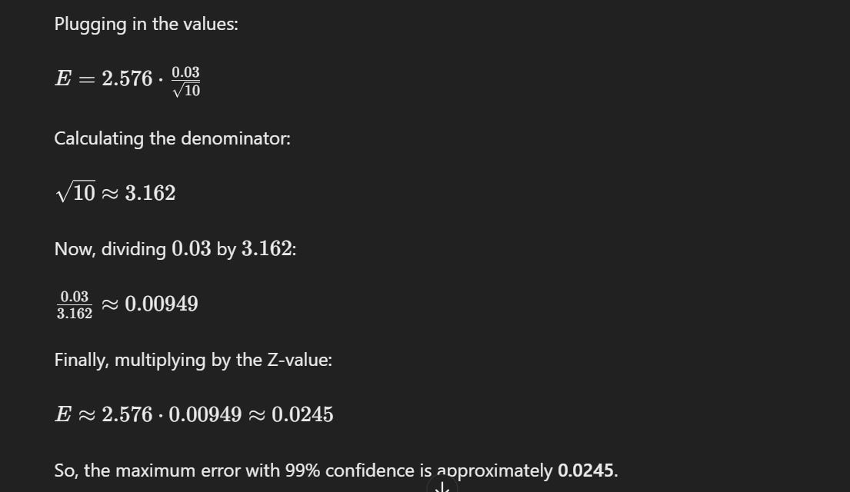

1. What are the properties of good Estimators

Good estimators should be unbiased, consistent, efficient, and sufficient.

1. Define Type – I & Type – II Errors

. *Type I & Type II Errors*:

- Type I Error: Rejecting a true null hypothesis (false positive).

- Type II Error: Failing to reject a false null hypothesis (false negative).

1. Assuming that ,how large a random sample be taken to assert with probability 0.95 that the sample mean will not differ from the true mean by more than 3.0 points?

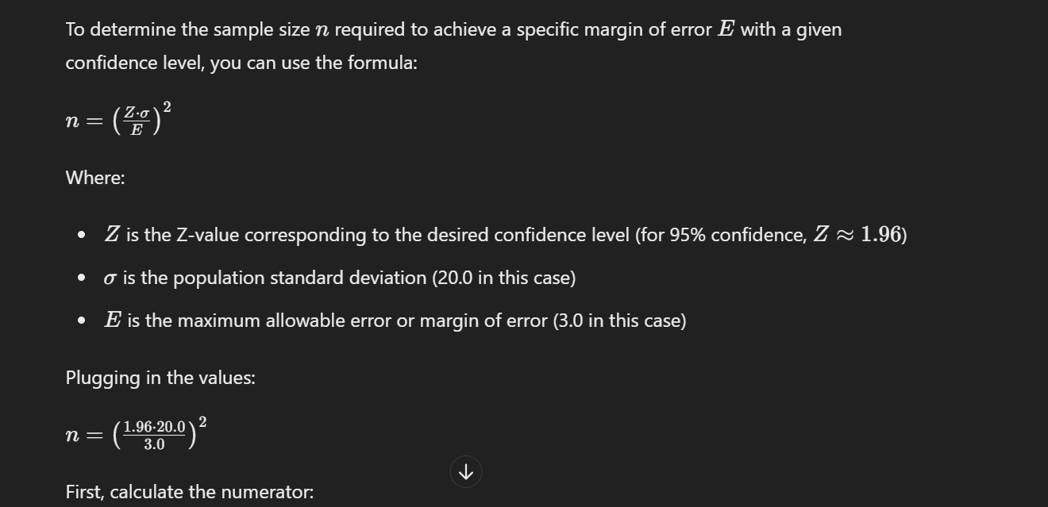

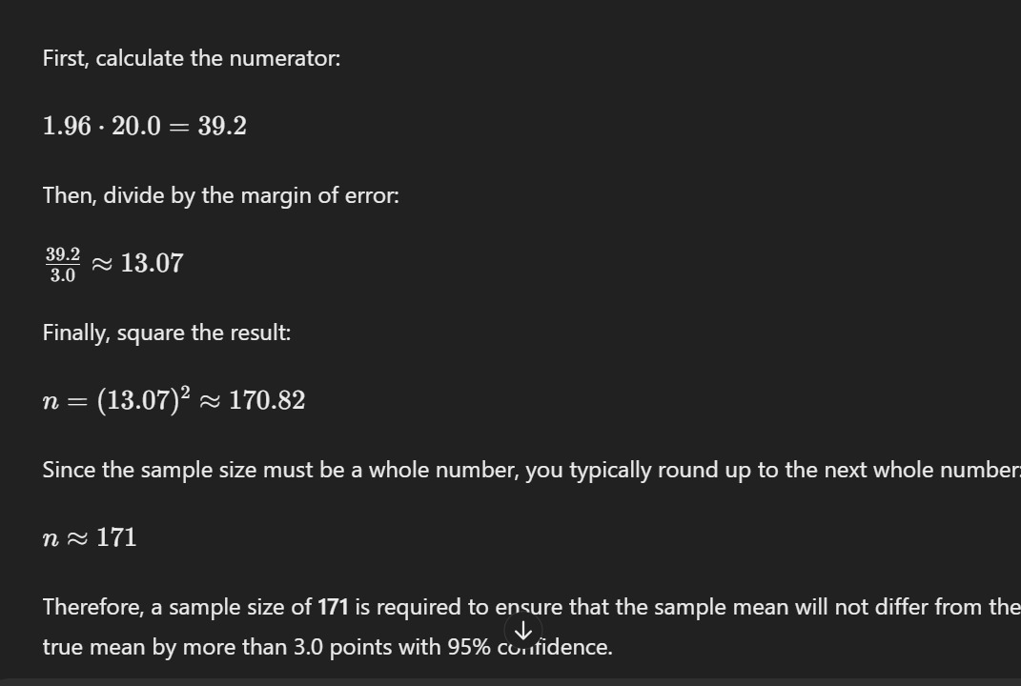

1. What can we say with 99% confidence about the maximum error, if 500 families have low income among 900 families?

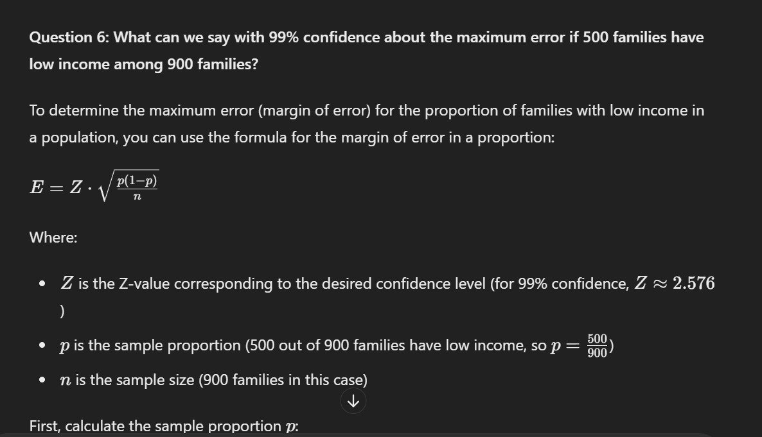

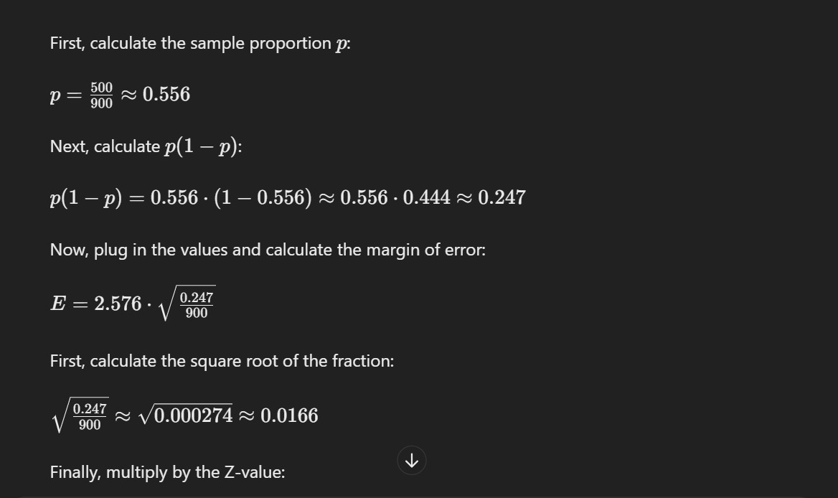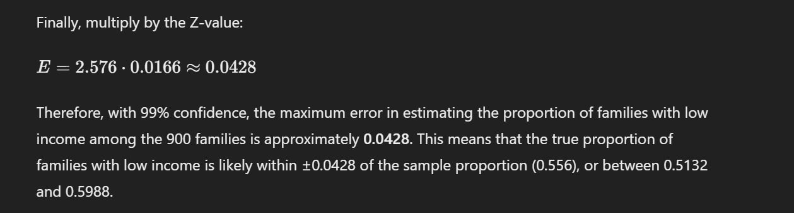

1. Define Markov process

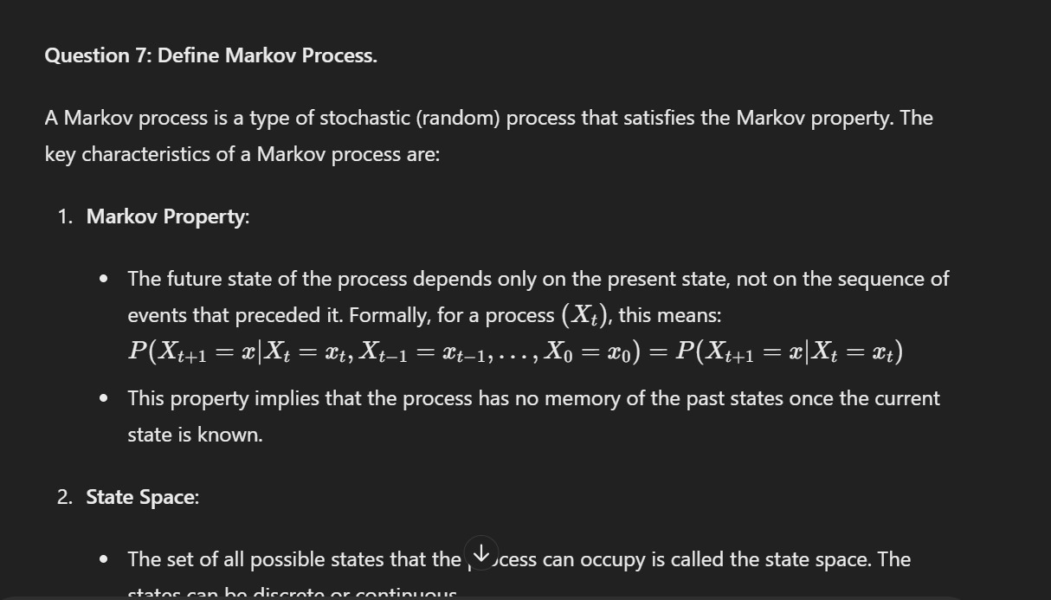

1. Define Stochastic Matrix

A square matrix used to describe the transitions of a Markov chain, where each row sums to 1.

1. If TPM is then find x, y, z

X=0.5

Y=0.3

Z=0.5

1. Which of the following Matrix is Stochastic matrix

2

Square matrix with positive numbers.and row sum=1

1. Find the value of finite population correction factor for n=10 and N=100.

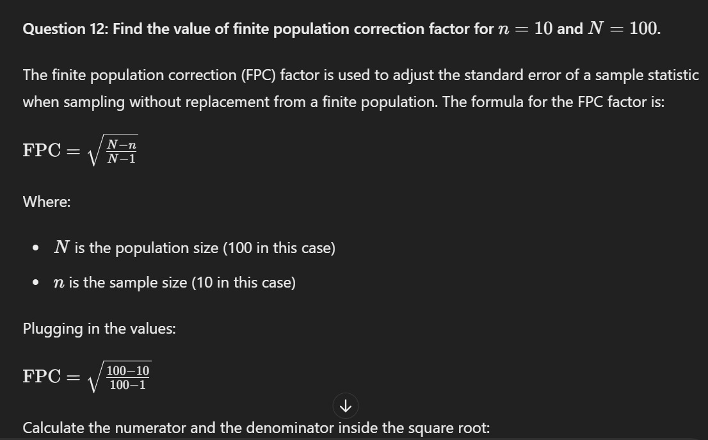

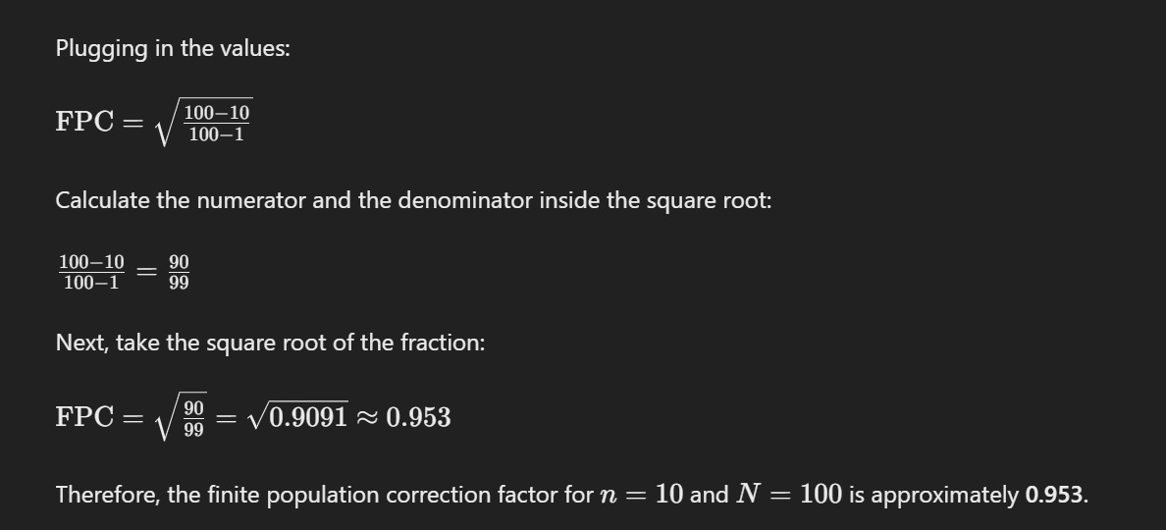

1. The variance of a population is 2. The size of the sample collected from the population is 169. What is the standard error of mean.

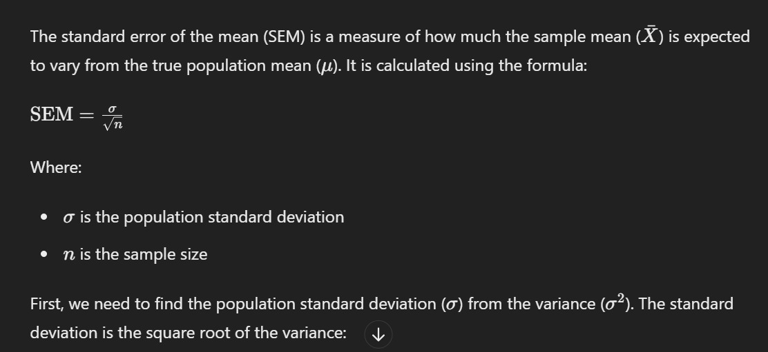

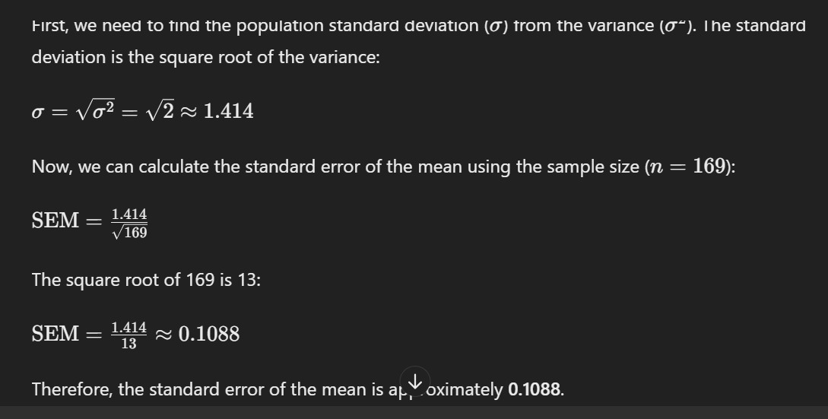

1. Define Null & Alternative Hypothesis.

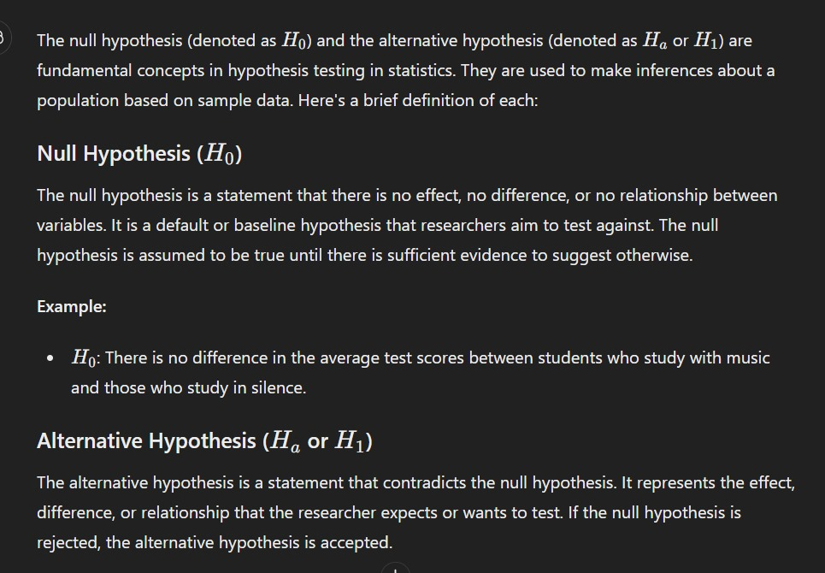

1. Define Type – I & Type – II errors.
2. Write any three characteristics of F-Distribution.

Non-negative values.

- Skewed to the right.

- Depends on two degrees of freedom.

1. Write the formula for testing the hypothesis for large sample concerning two means.

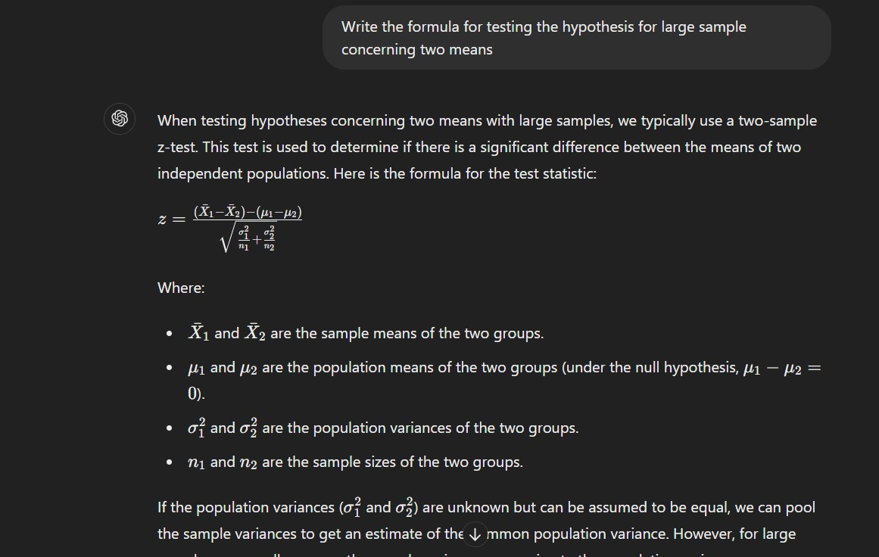

1. Define Stochastic matrix and give an example.
2. Define regular matrix. Is the matrix regular ?
3. Draw a transition diagram for the transition matrix
4. Define Probability vector & is the matrix probability vector?

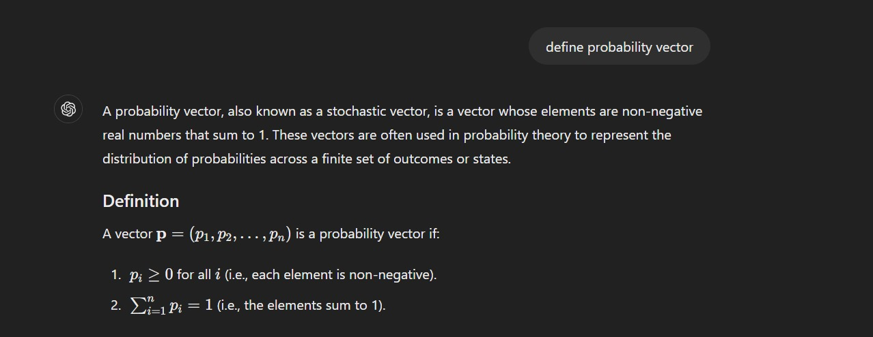

1. A population consisting of 1,5,6,8. Consider the all possible samples of size 2 with replacement from the population. Then Find

(a)The mean of the population

(b)Variance of the population

(c) Construct the sampling distribution of means

(d)Mean of the sampling distribution of means

(e)Variance of the sampling distribution of mean

(f) Verify with the formula

1. Two horses A and B were tested according to the time (in seconds) to run a particular track with the following results

|  |  |  |  |  |  |  |  |
| --- | --- | --- | --- | --- | --- | --- | --- |
| Horse A | 28 | 30 | 32 | 33 | 33 | 29 | 34 |
| Horse B | 29 | 30 | 30 | 24 | 27 | 29 | - |

Test whether the two horses have the same running capacity

1. An oceanographer wants to check whether the depth of the ocean in a certain region is 57.4fathoms, as had previously been recorded. What can he concluded at the level of significance α=0.05, if readings taken at 40 random locations in the given region yielded a mean of 59.1fathoms with a standard deviation of 5.2fathoms
2. A manufacturer of electronic equipment subjects samples of two completing brands of transistors to an accelerated performance test. If 45 of 180 transistors of the first kind and 34 of 120 transistors of the second kind fail the test, what can he conclude at the level of significance α=0.05 about the difference between the corresponding sample proportions?
3. The transition probability matrix of markov chain ,n=1,2,3….having states 1,2,3 is with initial distributions  Then find



1. If and initial probabilities are 

Find the probabilities after 3 periods

Find equilibrium vector

1. A population consists of five numbers 2, 3, 5, 6 and 8. Consider all possible samples of size two which can be drawn with replacement from this population. Find
   1. The mean of the population
   2. The standard deviation of the population.
   3. The mean of the sampling distribution of means and
   4. The standard deviation of the sampling distribution of means.

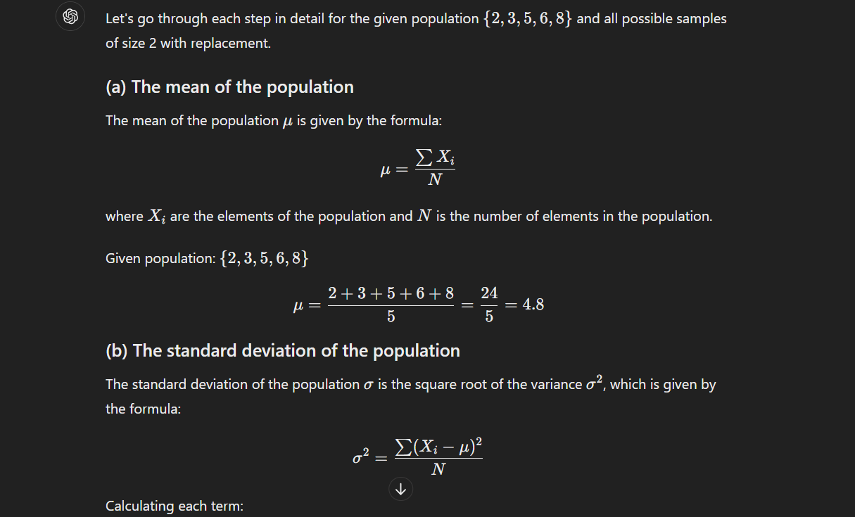

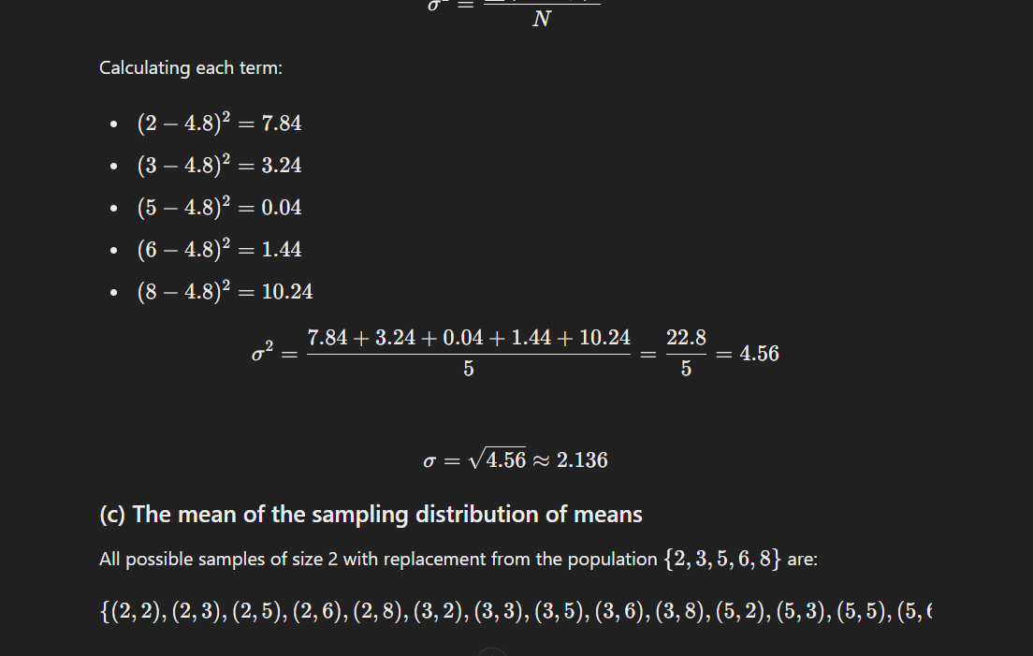

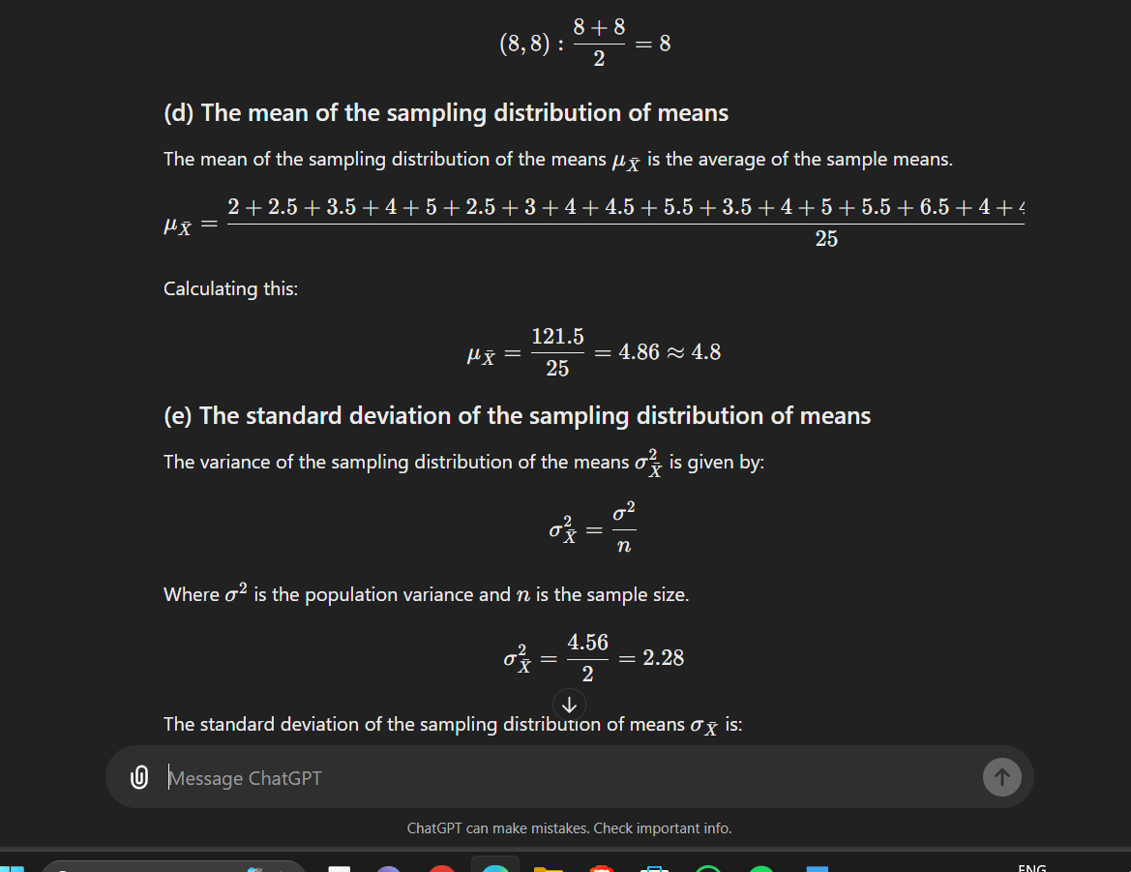

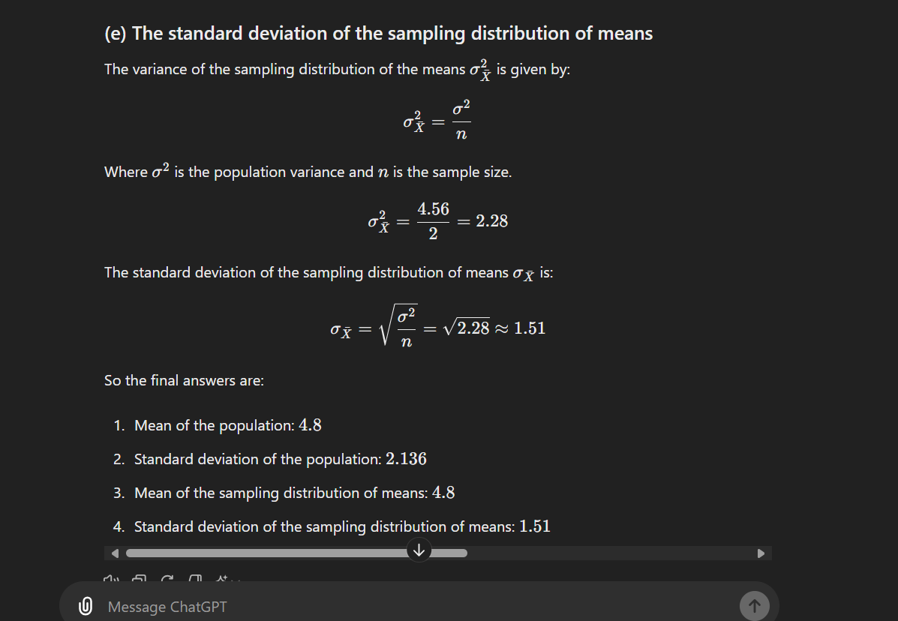

A random sample of size 64 is taken from a normal population with

1. . What is the probability that the mean of the sample will (a) exceed 52.9 (b) fall between 50.5 and 52.3 (c) be less than 50.6
2. A manufacturer of electronic equipment subjects samples of two completing brands of transistors to an accelerated performance test. If 45 of 180 transistors of the first kind and 34 of 120 transistors of the second kind fail the test. What can he conclude at the level of significance 5% about the difference between the corresponding sample proportions?
3. The transition probability matrix of a Markov chain { Xn} ; n=1,2,3, - - - having three states 1,2 and 3 is and the initial distribution is

then find

1. A gambler has Rs.2. He bets Rs. 1 at a time and wins Rs.1 with probability ½ . He stops playing if he loses Rs. 2 or wins Rs.3. (a) What is the transportation probability matrix of the related Markov chain ? (b) what is the probability that he has lost his money at the end of 4 plays.

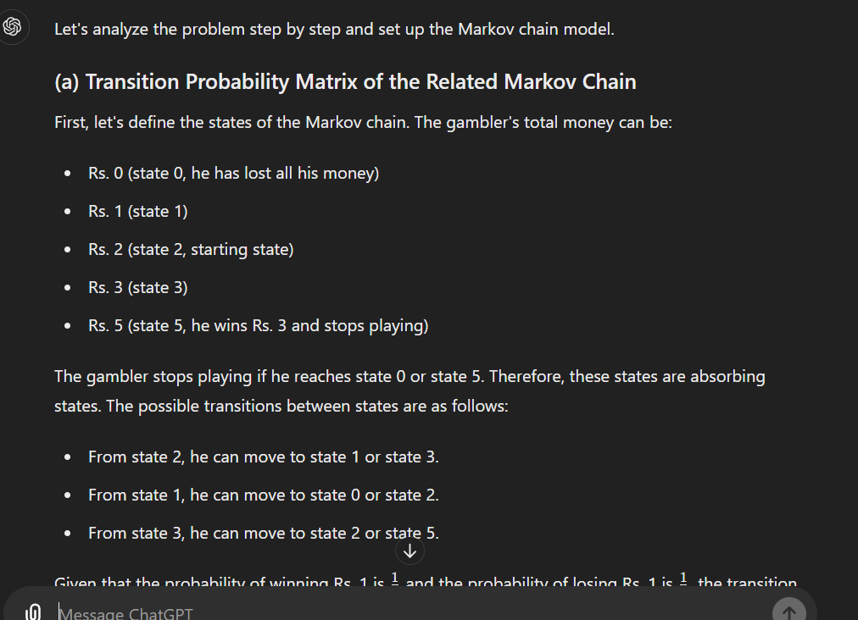 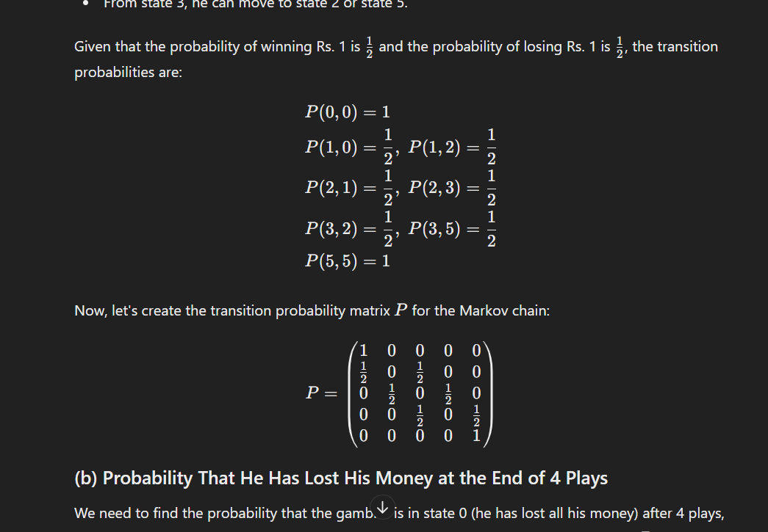

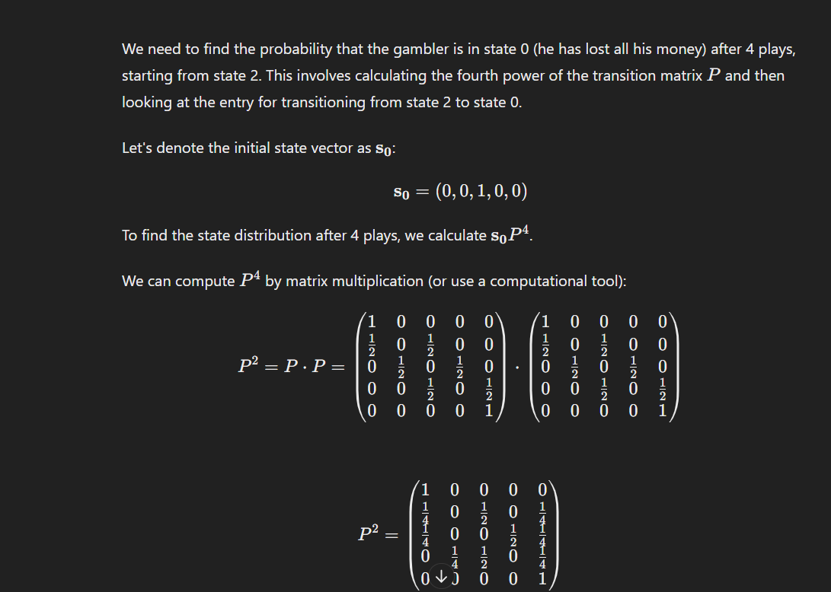

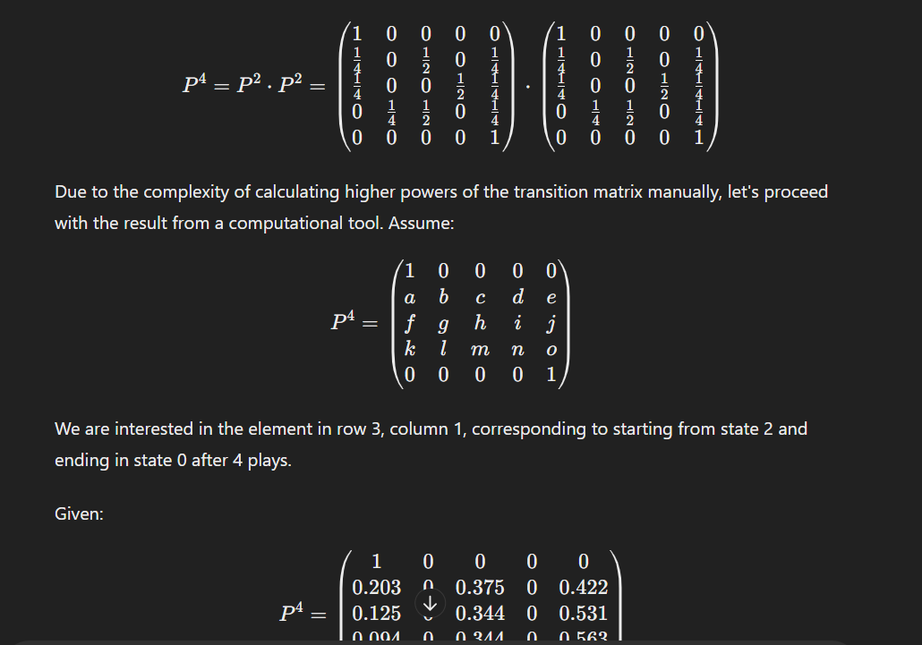

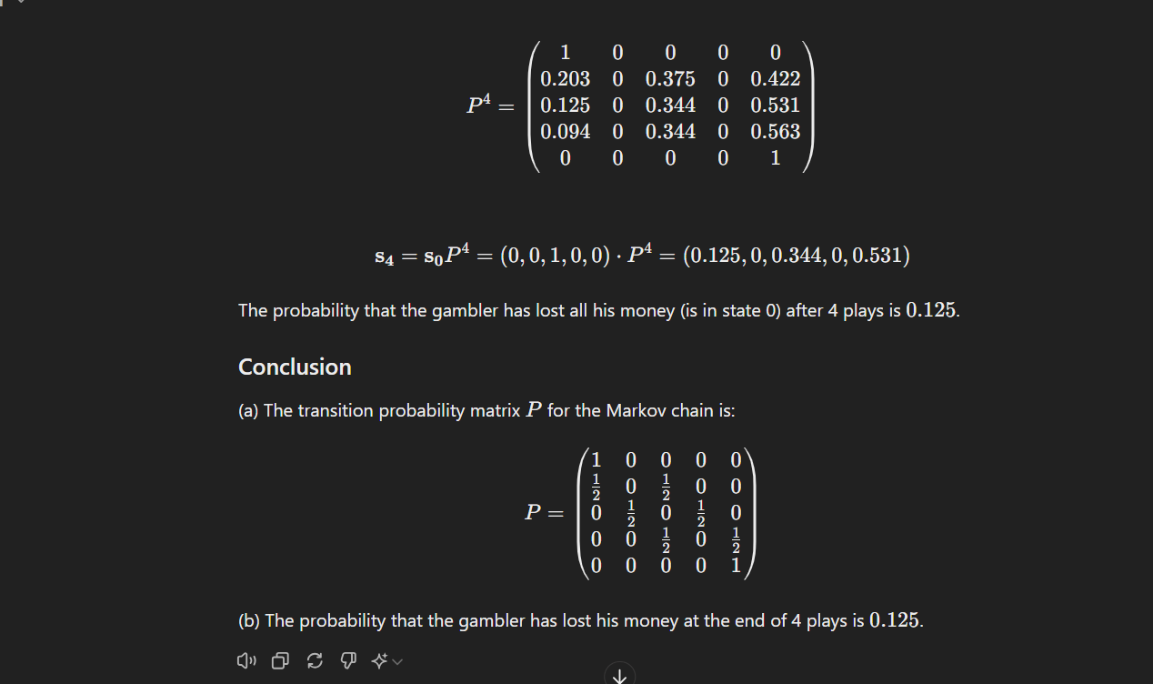

1. A random sample of 10 boys had the following I.Q.’s 70,120,110,101,88,83,95,98,107,100

Do these data support the assumption of a population mean I.Q. of 100

Find a reasonable range in which most of the mean I.Q values of the samples of 10 boys lie.

